Guidelines on Logos and branding
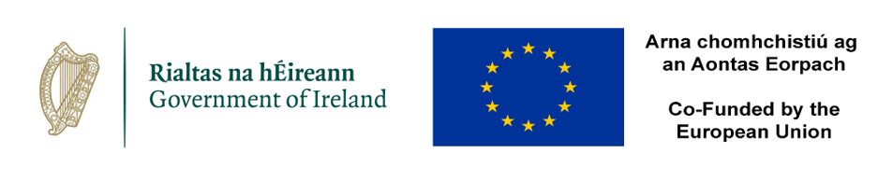
The key purpose of this sponsorship scheme is to enhance the visibility of EU Funds.

To ensure this is achieved it is essential that the relevant Logos and branding are appropriately used and applied to provide visibility for the Funds. While detailed information on branding and copies of the logos can be found on the gov.ie website the following is a brief outline/checklist of the key requirements.

- The Government of Ireland Mark and the EU Emblem (‘the logos’) must feature on all communication materials and must not be recreated or modified in any way.

- If additional logos are displayed, the logos must be at least the same size, measured in height or width, as the biggest of the other logos.

- The logos must be displayed in colour whenever possible including websites, but a grayscale version can be used only when colour is not possible.

- Beneficiaries must acknowledge the support received by highlighting the co-funding in a visible manner on all material intended for the public or participants.

- Where the Beneficiary has a website a short description of the support should be included mentioning the EU’s contribution with logos and funding statement. A link to the EU Funds website (www.eufunds.ie) should also be included.

- Where a social media account exists the EU support should be highlighted with the Irish flag and EU Flag emoji’s used to represent the co-funding. The hashtag #EUinmyregion should be used wherever possible.

- The EU Funds communication team can help to promote your events through its social media accounts. In order for this, please provide the appropriate details at least four days in advance to your programme activity.

- Following an event/activity the beneficiary must within two weeks provide the sponsor with details including any press release, social media posts, photos etc.

- Beneficiaries should maintain a communication file and retain evidence of communication activities.

